03/06/2019

CARLU FLORIAN

Projet Java

SQL Report

Table des matières

**I.** **Connection to the DataBase** 2

**II.** **The stored procedure** 3

**III.** **Table example** 4

# **Connection to the DataBase**

@Override

**public** Level find(**final** **int** id) {

Level level = **new** Level();

**try** {

**for**(**int** x=0; x<40; x++) {

**for**(**int** y=0; y<22; y++) {

**final** String sql = "{call LevelByID(?,?,?)}";

**final** CallableStatement call = **this**.getConnection().prepareCall(sql);

call.setInt(1, x);

call.setInt(2, y);

call.setInt(3, id);

call.execute();

**final** ResultSet resultSet = call.getResultSet();

**if** (resultSet.first()) {

level.constructLevel(x, y, resultSet.getString("C"+x));

}

}

}

**return** level;

} **catch** (**final** SQLException e) {

e.printStackTrace();

}

**return** **null**;

}

We call the sql request and implement the necessary parameters. It is an x, the column, a y, the line and an id to choose the table.

Each retrieved character is sent to the Level table by selecting the correct column.

# **The stored procedure**

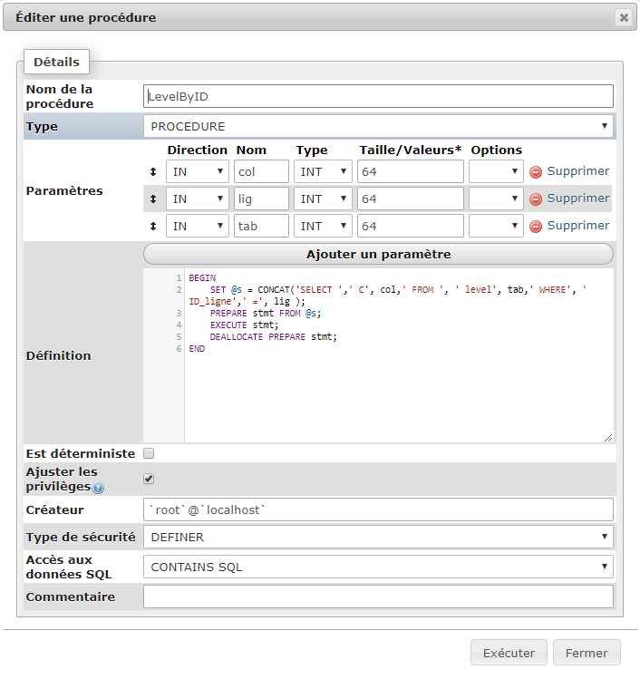

We give in parameter the column, the row and the id of the database. With dynamic sql, we create a concatenation of the query with these parameters. Then it is executed.

# **Table example**

Characters representing future objects.